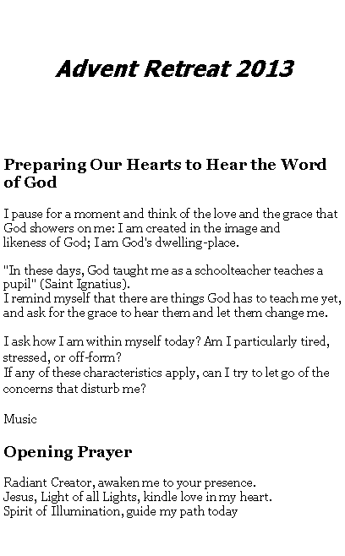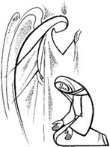

2nd Sunday of Advent, Year A

Mt 3:1-12

John the Baptist appeared, preaching in the desert of Judea and saying, “Repent, for the kingdom of heaven is at hand!” It was of him that the prophet Isaiah had spoken when he said:
A voice of one crying out in the desert,
Prepare the way of the Lord,
make straight his paths.
John wore clothing made of camel’s hair and had a leather belt around his waist.
His food was locusts and wild honey. At that time Jerusalem, all Judea, and the whole region around the Jordan were going out to him and were being baptised by him in the Jordan River as they acknowledged their sins.
When he saw many of the Pharisees and Sadducees coming to his baptism, he said to them, “You brood of vipers! Who warned you to flee from the coming wrath? Produce good fruit as evidence of your repentance. And do not presume to say to yourselves, ‘We have Abraham as our father.’ For I tell you, God can raise up children to Abraham from these stones. Even now the axe lies at the root of the trees. Therefore every tree that does not bear good fruit will be cut down and thrown into the fire. I am baptising you with water, for repentance,
but the one who is coming after me is mightier than I. I am not worthy to carry his sandals.
He will baptise you with the Holy Spirit and fire. His winnowing fan is in his hand.
He will clear his threshing floor

Questions for Reflection
Do I notice myself reacting as I pray with the Word of God? Do I feel challenged, comforted, angry? Imagining Jesus sitting or standing by me, I speak out my feelings, as one trusted friend to another.

Accepting the Challengers
John the Baptist prepared the way for the entrance of Jesus. John preached in such a way that minds and hearts were opened to hear the message of the Messiah when he arrived. On this second Sunday of Advent we might ask ourselves: Who are our messengers? How do they prepare the way for us to welcome the Christ in one another? Are we open and receptive to these unexpected envoys who can lead us to a fuller experience of the presence of God? Advent is the season to ready ourselves to receive the divine light, however it comes to us.

My messengers are many and varied. Sometimes they are good people who do not know they are Christ’s heralds of change. They are simply living their lives as best they can. They give witness to the divine light by how they love and generously give of themselves. Someone willing to donate a kidney, parents patiently loving and unselfishly giving of themselves for their children, long-term caregivers who extend continual kindness to the sick – all these messengers move me to be bigger-hearted and less self-orientated.

Sometimes welcoming Christ’s emissaries challenges me greatly. Not all of John the Baptist’s listeners wanted to hear his message. People I resist or do not especially like are also the prophets preparing the way for the Christ to enter my life. Such people are Emmanuel’s messengers too, because they help me to cast out the darkness of my egotism, prejudice and small-mindedness by shedding light upon the darkness of my closed, inner spaces.

Today
I will think about my messengers of light and write a note of gratitude to one of them

3rd Sunday of Advent, Year A
Gospel Mt 11:2-11
When John the Baptist heard in prison of the works of the Christ, he sent his disciples to Jesus with this question, “Are you the one who is to come, or should we look for another?” Jesus said to them in reply, “Go and tell John what you hear and see:
the blind regain their sight,
the lame walk,
lepers are cleansed,
the deaf hear,
the dead are raised,
and the poor have the good news proclaimed to them.
And blessed is the one who takes no offence at me.”
As they were going off, Jesus began to speak to the crowds about John, “What did you go out to the desert to see? A reed swayed by the wind? Then what did you go out to see? Someone dressed in fine clothing? Those who wear fine clothing are in royal palaces. Then why did you go out? To see a prophet? Yes, I tell you, and more than a prophet. This is the one about whom it is written:
Behold, I am sending my messenger ahead of you;
he will prepare your way before you.
Amen, I say to you, among those born of women there has been none greater than John the Baptist; yet the least in the kingdom of heaven is greater than he.”

Questions for Reflection
What feelings are rising in me as I pray and reflect on God's Word? I imagine Jesus himself sitting or standing near me and open my heart to him.

Fuelled by Faith
Jesus praised his much loved cousin, John the Baptist, on several occasions. He saw John as a burning and shining lamp, afire with enthusiasm. Jesus valued his cousin’s passionate commitment. Like a lamp whose flame burns steadily with sufficient oil, so John was filled with a confident belief that Jesus was the one whom all should follow. That is, until John was tossed into prison. Then the light of John’s lamp began to flicker. He sent his disciples back to Jesus to ask: “Are you the one who is to come, or should we look for another?” (Matthew 11:3)

The oil of faith that fed John’s lamp suddenly diminished because of his life’s drastic change. No longer was John in charge of his life. He sat in prison, unable to preach and bear witness. No doubt he felt he had failed, or worse, that he had been duped into a ministry that seemed hopeless.
I can identify with John the Baptist. Although I have never languished in prison as he did, I also experience the oil of faith in my own lamp diminish at time when things don’t go the way I want them to go. The oil level goes down when loved ones die, when my schedule gets overly pressured or when my hopes for world peace grow dim. It is easy to be alive and enthusiastic about the things of God when life is going well. When life takes a nose-dive, then it is challenging to be that radiant lamp of faith.

Today
I will refill the oil in my inner lamp by seeking more trust in God and letting go of discouragement

4th Sunday of Advent, Year A

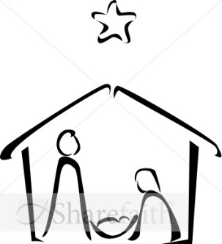
Gospel Mt 1: 18-24

This is how the birth of Jesus Christ came about.
When his mother Mary was betrothed to Joseph,
but before they lived together,
she was found with child through the Holy Spirit.
Joseph her husband, since he was a righteous man,
yet unwilling to expose her to shame,
decided to divorce her quietly.
Such was his intention when, behold,
the angel of the Lord appeared to him in a dream and said,
“Joseph, son of David, do not be afraid to take Mary your wife into your home.
For it is through the Holy Spirit
that this child has been conceived in her.
She will bear a son and you are to name him Jesus,
because he will save his people from their sins.”
All this took place to fulfill what the Lord had said through the prophet:
Behold, the virgin shall conceive and bear a son,
and they shall name him Emmanuel,
which means “God is with us.”
When Joseph awoke,
he did as the angel of the Lord had commanded him
and took his wife into his home.

Reflection
Remembering I am still in God’s presence, I imagine Jesus sitting or standing beside me and I say whatever is on my mind, whatever is in my heart, speaking as one friend to another.

Making New Plans
Mary said “YES” to God’s request to be the mother of Jesus. Fortunately for humankind, Joseph also responded positively to God’s invitation. When Joseph learned of Mary’s pregnancy he intended to keep his integrity. He made up his mind to be kind to Mary and divorce her quietly so she would not be exposed to shame. How alarmed and surprised Joseph was when he discovered more was expected of him. The angel’s words in his dream are the same as the angel’s to Mary: “Do not be afraid”. Any peace Joseph might have had about his original decision flew swiftly away. The angel’s appearance startled Joseph, but what really shook Mary’s future husband was God’s request to revisit his carefully worked out plan and revise his intentions.

The dream held out a huge spiritual opportunity for Joseph. He could have left Mary, opted out of any personal responsibility and gone on with his life. Socially and legally, this would have been acceptable. There was so much risk involved in saying “yes” to God. Yet Joseph found enough faith and courage to discard his original plan. He was generous with his love and unselfish to the point of risking his reputation and future by marrying a young pregnant girl whose child was not his. What a magnificent Light-Bearer Joseph was! His witness gives each of us the courage to let our carefully carved out plans unravel a bit when God invites us to take a risk for the sake of loving another.

Today
I will risk saying a kind word or doing a good deed for the sake of love.

Closing Prayer (each day)
Emmanuel, you are the Everlasting Light. Help me to bring your love everywhere I go.
Penetrate and possess my whole being so fully this Advent that all my life will be a radiance of you. Shine through me and be so in me that everyone I come in contact with today may feel your presence in my spirit. Let them look and see, not just me, but you, Light of all Lights, shining through me. Amen
(adapted from John Cardinal Newman’s prayer)

As you blow out the candle and the light is gone, remember you have a divine light within you that will never go out. You take the light of Christ with you into your day.

(Reflections on the Gospel readings for the 2nd, 3rd and 4th Sunday of Advent and the Opening and
Closing prayers were taken from ‘Welcome the Light: Daily Devotions for Advent’ by Joyce Rupp O.S

